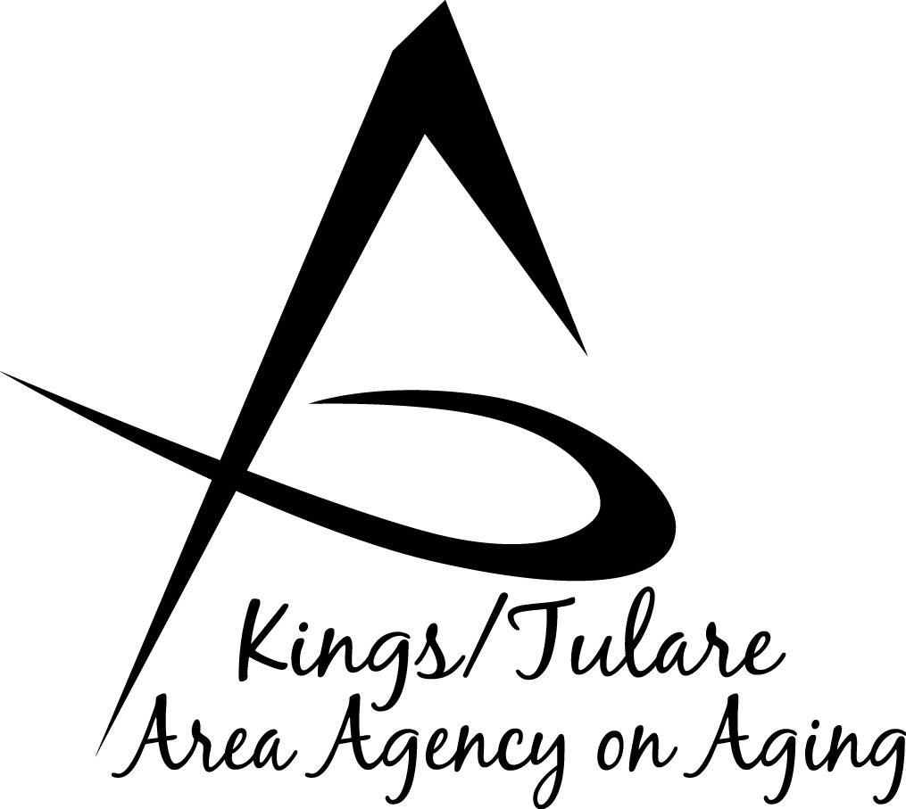
GOVERNING BOARD MINUTES

To be approved on: Minutes of the January 28, 2019 meeting

March 18, 2019 at Tulare Co. Board of Supervisors Bldg. ………………………………………………………2800 W. Burrel Ave., Visalia, CA 93212

GOVERNING BOARD MEMBERS PRESENT:
Richard Fagundes, Kings Co. – Dist. 5
Pete Vander Poel, Vice Chair Tulare Co. – Dist. 2
Amy Shuklian, Tulare Co. – Dist. 3
Craig Pedersen, Kings Co. – Dist. 4
Eddie Valero, Tulare Co. – Dist. 4

GOVERNING BOARD MEMBERS ABSENT:
None

COUNCIL MEMBERS PRESENT:
Marlene Chambers
Sharon Lamagno
Ms. Bobbie Wartson
Dr. David Wood, Council Chair
Suzann Wray

STAFF PRESENT:
Juliet Webb, K/T AAA Director
Jamie Sharma, Tulare Co. Aging Services Mgr.
Matthew Kredit, Administrative Specialist
Bonnie Quiroz, Adult Family Advocate
Israel Guardado, Staff Services Analyst
Christine Tidwell, Administrative Aide

GUESTS PRESENT:
Roger Bradley, Assistant CAO, Kings County
Sanja Bugay, Director, Kings County
Human Services Agency
Rebecca Campbell, CAO, Kings County
Albert Cendejas, CSET

- Call to Order – Supervisor Pederson, Chair, called the meeting to order at 10:01 a.m.

- Introductions – Attendance as above. Eddie Valero, the Tulare County Supervisor newly appointed to the K/T AAA Governing Board, introduced himself. He is taking over the Supervisorial seat formerly held by Steve Worthley, District 4. He is a native resident of Cutler Orosi and has served on the School Board for Cutler Orosi Joint Unified for 6 years, 3 years as President. Supervisor Valero spent 10 years doing undergraduate and graduate work at Cornell and Georgetown Universities, after which he decided to return to Tulare County to help improve the local communities.

- Board Member Comments – None.

- Public Comment – Albert Cendejas commented that CSET will be doing the Volunteer Income Tax Assistance (VITA) in both Kings and Tulare Counties. The service will be available at all the senior centers, including Dinuba (Dinuba Senior Center is not under the umbrella of the K/T AAA). Flyers were distributed with further details and locations, including Earlimart, Traver, Pixley and all areas of the County, both north and south, including the mobile services. Days in which the volunteers are at the senior centers, the services are dedicated to the seniors, to avoid them having them to wait in long lines. Appointments are available.

Supervisor Shuklian questioned why there were no dates for the Visalia Senior Center. Mr. Cendejas said that CSET hasn’t connected with the Visalia site, but is doing its best to connect with that center to establish a date. Ms. Shuklian offered help in making that connection, if it is needed. Kings County Commission on Aging (KCCOA) also has volunteers helping with income tax preparation three days a week.

Ms. Wartson announced that KCCOA held a community breakfast at the Tachi Palace which garnered over $9,000 ($9,466) to be used for senior services in Kings County.

Advisory Council member Suzann Wray commented that the food distribution program out of Open Gate serving Dinuba/Cutler/Orosi will be discontinued. Supervisor Valero said that he had also heard this was being discontinued, but had not confirmed it. He said he will be looking into it.

- Approval of Minutes of July 30, 2018 – A motion to approve the minutes of the October 15, 2018, meeting was made by Supervisor Shuklian and seconded by Supervisor Fagundes. On a motion and a second the minutes were approved.

- Election of Chair and Vice Chair for 2019 – Supervisor Vander Poel motioned that Supervisor Shuklian be voted in as Board Chair for 2019 and that Supervisor Fagundes take the position of Vice Chair. Supervisor Valero seconded the motion, which carried on a unanimous vote. The gavel was passed to Supervisor Shuklian who took over chairing the remainder of the meeting. (Vander Poel/Valero Res. No. 19-001)

- Governing Board Meeting Schedule – The Board considered approving the meeting schedule as proposed and presented, with the community meetings being held at the Woodlake Senior Center in Tulare County and the Kings County community meeting to be at the Hanford Senior Center at the View Road Apartments. However, Supervisor Vander Poel asked if any meetings could be held in any of the unincorporated areas of either County. Ms. Webb, K/T AAA Director stated that there are none scheduled at this time. Supervisor Vander Poel commented that he would like to see at least one meeting a year in an unincorporated area – if, for instance one of the meetings that is scheduled to be at the Board of Supervisors building instead could be conducted in an unincorporated part of either county, he would appreciate it. The July meeting was suggested for this, but often the July meeting is canceled due to a light agenda. Ms. Webb will work with staff on this. Supervisor Vander Poel said even if one of the community locations was moved to an unincorporated location that would be fine, too. Ms. Webb asked if there was a specific recommendation on a location that he would like to see. Supervisor Vander Poel said he understands that sometimes logistics dictates where the meetings occur.

Supervisor Shuklian commented that the proposed July date is in conflict with the National Assoc. of Counties (NACo) conference, which she plans to attend. Ms. Webb said that historically, the July meeting is one that has been more flexible (and often canceled) unless there is pressing business that needs attention, in which case it will be brought back to the Board for a different date.

Supervisor Shuklian asked for a motion to accept the schedule other than the proposed changes. Supervisor Pedersen motioned to accept; Supervisor Vander Poel seconded the motion. The vote carried. (Pedersen/Vander Poel Res. No. 19-002)

- Update on the California Department of Aging – Ms. Webb said this is an item being brought before the Board, but asked that the item be moved to later in the agenda in anticipation of the Tulare County CAO being able to join the discussion. The item was moved to the end of the agenda.

- CA Dept. of Aging Health Insurance Counseling & Advocacy Program (HICAP) Amendment #2 – Mr. Guardado said this is an information item regarding the HICAP budget, Amend. #2. HI-1718-15 is a three year agreement between the CDA and the K/T AAA, spanning from July 1, 2017, to June 30, 2020. In December 2017, CDA released a contract Amendment #1, which included a decrease of $41,236. In November of 2018 the CDA announced it would be releasing Amendment #2, which has already been released that included some minor changes to the contract language, some new provisions, and some budget adjustments. The budget adjustment includes a carryover amount of $13,838 – Federal funds from FY1718 to FY1819. Unused funds moved from the previous year to this year. Additionally, the CDA has included funding based on the 2017 Federal SHIP grant for the period April 1, 2020 to June 30, 2020 that was previously not included. The new budget amount is $878, 044. Resolution 10-021 authorized the Director to accept the change in funds, as the change is less than 10% of the total budget. The funds have already been accepted.

- California Senior Legislature (CSL) Travel, Expense and Reimbursements – Ms. Webb said that the Council has two of its members, Dr. David Wood and Ms. Bobbie Wartson as representatives on the CSL. The CSL is not a K/T AAA-affiliated organization and doesn’t have to do with CDA or the AAA business. It is advantageous to have Council members representing the K/T AAA and who can advocate on behalf of Kings and Tulare Counties, but it is outside of the authorized expenditures for the Area Agency. There have been requests from Dr. Wood to travel to the CSL meetings and functions. CSL does reimburse for travel, but they have strict limits on what will be reimbursed. For instance, lodging is limited to the night of the event and CSL will not pay for two nights of lodging. Previously, an additional night of lodging was authorized to be paid by the K/T AAA; however, according to the regulations, this is outside of the Directors authority. Therefore, this issue is being brought before the Governing Board. If the Board had a resolution authorizing the K/T AAA Director to approve such travel expenses that are beneficial to the Agency that would give the Director authority to do so. For that reason it is being brought to the Board for authorization.

Dr. Wood, Advisory Council Chair and CSL Senator, stated that the CSL has a limited budget that is approved by the California Legislature, noting that per diem and travel is allowed but it is a restricted budget. He noted that sometimes it is necessary to be in Sacramento in advance of the meeting. For instance, he is now part of the Policies and Procedures and the Senate Health Committees so it requires more time, and this will be helpful if an overnight stay is needed. Steering committees meet on a quarterly basis. He noted that taking the Amtrak may also be an option if the schedules correspond.

Supervisor Vander Poel said he feels it important for the Board to take an action not only for this instance but for future instances as well, when travel or reimbursement is necessary for the betterment of the organization or anything that would be positively enhancing for it. He reiterated that he feels that authority should reside with the K/T AAA Director. He requested that in the future a policy be brought back to the Board, but for right not, he said he is fine with approving it as suggested. Ms. Webb stated that a resolution will be prepared to bring to the next Board meeting. Supervisor Peterson asked if a budget adjustment is needed to accommodate this; Matthew Kredit said no budget change will be required. He also said that CDA had simply asked if this is a “necessary and reasonable” expense. Supervisor Vander Poel motioned that a formal resolution should be brought for approval on this matter; Supervisor Valero seconded the motion, which passed unanimously.

- 2018 Year in Review – Aging Services Manager, Ms. Jamie Sharma, narrated a Powerpoint presentation on the highlights and team events of the K/T AAA for 2018. Supervisor Vander Poel said he appreciates these presentations and it’s a great way to kick off the new year, by reviewing all the services that are being provided to the seniors.

- Staff Reports
- Matthew Kredit said that the Administrative Specialist position with the K/T AAA that he held is currently vacant and that he has accepted the position of Human Services Budget Officer.
- Ms. Sharma announced that the K/T AAA Auditors, R. J. Ricciardi, Inc., are currently here starting today, with the anticipated exit meeting slated for Wednesday.

- Advisory Council Report
- Council Chair, Dr. Wood, said the Council has been busy trying to increase the visibility of the K/T AAA at the state level including attendance at the Triple A Council of California – the Association of the 33 Area Agencies on Aging throughout California. Ms. Bobbie Wartson is the K/T AAA representative. Additionally, he said that Ms. Wartson (Assembly) and he (Senate) participate in the CSL.
- In terms of membership, long-time member, Kyle Melton, resigned off the Council in December after 15 ½ years of membership. Cece Bobst was recently appointed by the Board, so, he acknowledged there is always an ebb and flow of volunteers. He said the Council has a second candidate, Ms. Judie Casey, who hopefully will be appointed soon. He noted there is some unusual politics with the Tule River Elders Council regarding Betsey Foote, in that the Elder Council clarified that she is no longer a “spokesperson” formally for the Tule River Elder Council. However, she remains active as a K/T AAA Council member. He said he has asked the tribe to formally designate a person who can act as a representative of the Elder Council and Tule River Tribe, and service on the Advisory Council. That is pending.
- Dr. Wood said he is also working with the Tule River Tribe on a Fall Prevention grant, noting that falls are a major source of injury for elders. This will be a pilot project.
- In keeping with the TACC meetings, the K/T AAA Advisory Council creates a quarterly meeting report, with the idea to provide an annual report for the Governing Board in terms of detailing what the Advisory Council has been doing throughout the year.

*Item number 8, which had been postponed earlier in the meeting, came up for discussion at this point.
8. Update on the California Department of Aging (CDA), continued – Ms. Webb presented the California Department of Aging’s perspective to the Governing Board regarding a funding issue, after which Ms. Bugay, Kings County Human Services Agency Director, presented Kings County’s perspective to the Board. Several members of the Board asked questions. It was requested that a formal letter from the CDA be brought to the next meeting.

- Adjourn – The meeting was adjourned at 11:41 a.m.

Respectfully submitted,

Juliet Webb

K/T AAA Director

